R. V. COLLEGE OF ENGINEERING

DEPARTMENT OF COMPUTER SCIENCE AND ENGINEERING
(Autonomous Institution Affiliated to VTU)
Bangalore – 560 059
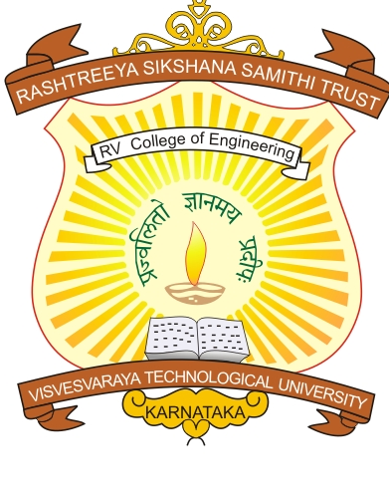

A Project report for System Software Lab on
“Implementation of 2-pass Assembler for Working Model of 8086”

Submitted in partial fulfillment of the requirements for the award of the degree of

Bachelor of Engineering
in

Computer Science & Engineering

by

SHREYA R. KAMATH | 1RV09CS099
SHRUTHI R. | 1RV09CS101

Carried out at
R. V. College of Engineering
Department Of Computer Science & Engineering

Bangalore – 560 059

(Academic Year : 2011-12 )

R. V. COLLEGE OF ENGINEERING

DEPARTMENT OF COMPUTER SCIENCE AND ENGINEERING,
(Autonomous Institution Affiliated to VTU),
Bangalore – 560 059
CERTIFICATE

This is to certify that the project work entitled “Implementation of 2-pass assembler for Working model of 8086” for the system software lab, is a bonafide work carried out by SHREYA R. KAMATH [1RV09CS099] and SHRUTHI R. [1RV09CS101] in partial fulfillment for the V semester of Bachelor of Engineering in Computer Science and Engineering of R.V.C.E, an Autonomous Institution Affiliated to VTU , during the year 2011-2012.

Signature of the Lab In-charge Signature of the HOD

Name of the Examiners Signature with Date

1. …………………………. ………………………

2. …………………………. ………………………

ACKNOWLEDGEMENTS

The euphoria and satisfaction of the completion of project will be incomplete without thanking the persons responsible for this venture.

We acknowledge VTU for providing an opportunity to create a mini-project in 5th semester. We express our gratitude towards Prof. B.S. Satyanarayana, Principal,RVCE for constant encouragement and facilitates extended in compilation of this project. We would like to thank Prof. Srinath N K, HOD of CSE for providing excellent lab facilities for the completion of project. We would personally like to thank our project guides Ms. Anupama H S and Ms.Vishalakshi and also lab in charge, for providing timely assistance & guidance at the appropriate time.

We are indebted to the co-operation given by lab administrators and lab assistants, who have played a major role in bringing out the mini-project in the present form.

Shreya R. Kamath
Vth Semester,CSE
USN:1RV09CS099

Shruthi R.
Vth Semester,CSE
USN:1RV09CS101

